# CUSTOMER SHOPPING SEGMENTATION BY USING MACHINE LEARNING

AN INDUSTRY ORIENTED MINI REPORT

Submitted to

**JAWAHARLAL NEHRU TECNOLOGICAL UNIVERSITY, HYDERABAD**

In partial fulfillment of the requirements for the award of the degree of

**BACHELOR OF TECHNOLOGY**

**In**

**COMPUTER SCIENCE AND ENGINEERING(AI&ML)**

Submitted By

**SHIVANI BATHINI 21UK1A6608**

**MANEESHA KANUKUNTLA 21UK1A6640**

**GANESH MACHERLA 21UK1A6627**

**SHASHANK CHILUKAMUKKU 21UK1A6653**

Under the guidance of

**Mr. T. Sanath Kumar**

Assistant Professor



## DEPARTMENT OF COMPUTER SCIENCE AND ENGINEERING VAAGDEVI ENGINEERING COLLEGE

Affiliated to JNTUH, HYDERABAD

BOLLIKUNTA, WARANGAL (T.S) – 506005

**DEPARTMENT OF**

**COMPUTER SCIENCE AND ENGINEERING(AI&ML)**

## VAAGDEVI ENGINEERING COLLEGE(WARANGAL)



**CERTIFICATE OF COMPLETION**

**INDUSTRY ORIENTED MINI PROJECT**

This is to certify that the UG Project Phase-1 entitled “CUSTOMER SHOPPING SEGMETATION BY MACHINE LEARNING” is being submitted by SHIVANI BATHINI (21UK1A6608), MANEESHA KANUKUNTLA (21UK1A6640), GANESH MACHERLA (21UK1A6627) SHASHANK CHILUKAPUKKU (21UK1A6667) in

Partial fulfilment of the requirements for the award of the degree of Bachelor of Technology in Computer Science & Engineering to Jawaharlal Nehru Technological University Hyderabad during the academic year 2024-2025

**Project Guide HOD**

**Mr. T. Sanath Kumar Dr. K. Sharmila**

(Assistant Professor) (Professor)

**External**

# ACKNOWLEDGEMENT

We wish to take this opportunity to express our sincere gratitude and deep sense of respect to our beloved **Dr .P. PRASAD RAO,** Principal, Vaagdevi Engineering College for making us available all the required assistance and for his support and inspiration to carry out this UG Project Phase-1 in the institute.

We extend our heartfelt thanks to **Dr.K.SHARMILA**, Head of the Department of CSE, Vaagdevi Engineering College for providing us necessary infrastructure and thereby giving us freedom to carry out the UG Project Phase-1.

We express heartfelt thanks to Smart Bridge Educational Services Private Limited for their constant supervision as well as for providing necessary information regarding the UG Project Phase-1 and for their support in completing the UG Project Phase-1.

We express heartfelt thanks to the guide, **T. SANATH KUMAR,** Assistant professor, Department of CSE for his constant support and giving necessary guidance for completion of this UG Project Phase-1.

­­­­­-

Finally, we express our sincere thanks and gratitude to my family members, friends for their encouragement and outpouring their knowledge and experience throughout the thesis.

**SHIVANI BATHINI (21UK1A6608)**

**MANEESHA KANUKUNTLA (2UK1A6640)**

**GANESH MACHERLA (21UK1A6627)**

**SHASHANK CHILUKAMUKKU (21UK1A6653)**

.

# ABSTRACT

This study applies machine learning techniques to segment customers based on their shopping behaviors, using transactional data from a large retail chain. By employing algorithms such as K-means clustering and hierarchical clustering, we identify distinct customer segments, including "bargain hunters," "loyal customers," "seasonal shoppers," and "high spenders." These segments provide valuable insights into customer profiles, enabling businesses to tailor marketing strategies, personalize customer experiences, and optimize promotional efforts. The segmentation's effectiveness is evaluated using metrics like silhouette score and Davies-Bouldin index, demonstrating that machine learning-driven customer segmentation enhances customer relationship management and strategic decision-making, ultimately fostering increased customer loyalty and business growth.

**TABLE OF CONTENTS**:-

1. **INTRODUCTION ...................................................................... 5** 
   1. **OVERVIEW… ......................................................................... 5**
   2. **PURPOSE ................................................................................. 5**
2. **LITERATURE SURVEY .......................................................... 8** 
   1. **EXISTING PROBLEM ........................................................... 8**
   2. **PROPOSED SOLUTION ..................................................... 8-9**
3. **THEORITICAL ANALYSIS… .............................................. 10** 
   1. **BLOCK DIAGRAM ............................................................... 10**
   2. **HARDWARE /SOFTWARE DESIGNING ................... 10-11**
4. **EXPERIMENTAL INVESTIGATIONS ........................... 12-13**
5. **FLOWCHART… ...................................................................... 14**
6. **RESULTS… ......................................................................... 15-18**
7. **ADVANTAGES AND DISADVANTAGES… ....................... 19**
8. **APPLICATIONS ...................................................................... 20**
9. **CONCLUSION ......................................................................... 20**
10. **FUTURE SCOPE… .............................................................. 21**
11. **BIBILOGRAPHY ............................................................. 22-23**
12. **APPENDIX (SOURCE CODE)&CODE SNIPPETS .... 24-30**

## 1.INTRODUCTION

**1.1.OVERVIEW**

Customer shopping segmentation by using machine learning involves a systematic approach to divide a customer base into distinct and actionable groups based on various data points such as shopping behaviors, demographics, transaction histories, and engagement metrics. This process begins with extensive data collection from multiple sources, including purchase history, website interactions, and customer feedback. Once collected, the data undergoes preprocessing steps like cleaning, normalization, and encoding to ensure it is ready for analysis. Feature selection identifies the most relevant variables that will help in accurate segmentation. Various machine learning algorithms, such as K-Means Clustering, Hierarchical Clustering, DBSCAN, and Gaussian Mixture Models, are then employed to identify patterns and group similar customers together. The resulting segments are analyzed to understand their unique characteristics, such as purchasing habits and preferences. Businesses use these insights to develop targeted marketing campaigns, personalized product recommendations, and strategies to enhance customer retention. Continuous monitoring and updating of the segmentation model ensure it remains relevant as customer behaviors and market conditions evolve, facilitating ongoing refinement of marketing strategies and business decisions.

4o

**1.2.PURPOSE**

Customer shopping segmentation using machine learning serves several purposes, primarily aimed at understanding and catering to the diverse needs and behaviors of customers. Here are some key purposes:

1. Targeted Marketing Campaigns: By segmenting customers based on their shopping behaviors, preferences, demographics, and purchasing patterns, businesses can tailor marketing campaigns that marketing messages resonate better with specific customer segments, leading to higher engagement and conversion rates.

2. Personalized Customer Experience: Machine learning segmentation allows businesses to personalize the shopping experience for each customer segment. This could involve recommending products based on past purchases, suggesting relevant promotions, or providing personalized offers that align with individual preferences.

3. Optimized Product Assortment: Understanding customer segments helps businesses optimize their product offerings. By analyzing which products appeal most to different segments, businesses can adjust their inventory and product assortments to meet customer demand more accurately.

4. Improved Customer Retention: Segmentation enables businesses to identify high-value customers and understand their needs better. By focusing on retaining these customers through personalized incentives, loyalty programs, or enhanced customer service, businesses can improve customer retention rates and reduce churn.

5. Operational Efficiency: Segmenting customers can also optimize operational processes such as inventory management, pricing strategies, and resource allocation. By predicting demand patterns for different segments, businesses can streamline operations and reduce costs.

6. Market Basket Analysis: Machine learning can uncover correlations and patterns in customer purchase behaviors, leading to insights like which products are frequently bought together (market basket analysis). This information can guide cross-selling strategies and bundle offerings.

7. Competitive Advantage: Businesses that effectively utilize customer segmentation through machine learning gain a competitive edge by being more responsive to customer needs and preferences. This can lead to increased market share and profitability.

Overall, customer shopping segmentation through machine learning empowers businesses to understand their customers at a deeper level, enhancing marketing effectiveness, improving customer satisfaction, and driving business growth.

## 2.LITERATURE SURVEY

**2.1 EXISTING PROBLEM**

1. **Data Quality and Availability**:

* **Privacy Concerns**: Collecting detailed customer data raises privacy concerns and regulatory compliance issues (GDPR, CCPA), which limit the availability of comprehensive datasets.

2. **Feature Engineering**:

* **High Dimensionality**: Customer data often includes numerous features, making it challenging to select relevant features for effective segmentation.
* **Dynamic Customer Behavior**:Customer preferences and behaviors change over time, requiring continuous feature updates and model retraining.

3. **Model Selection and Evaluation**:

* **Choosing the Right Algorithm**: Different algorithms (e.g., k-means, hierarchical clustering, DBSCAN) have various strengths and weaknesses. Selecting the appropriate one for specific segmentation tasks is not straightforward.
* **Scalability**: Many clustering algorithms struggle with scalability when dealing with large datasets, leading to performance bottlenecks.

4. **Interpretability**:

* **Black-Box Models**: Many advanced ML models (e.g., neural networks) offer high accuracy but lack interpretability, making it difficult for businesses to trust and act on the segmentation results.

5. **Handling Imbalanced Data**:

* **Unequal Segment Sizes**: Real-world customer data often leads to segments of vastly different sizes, which can bias models and affect the performance of segmentation.

**2.2 PROPOSED SOLLUTION**

Addressing the challenges in customer segmentation using machine learning involves a comprehensive approach that combines advanced techniques, best practices, and iterative improvements. Here’s a proposed solution that aims to tackle the common problems identified in the literature:

#### 1. Data Quality and Availability

* **Data Cleaning and Preprocessing**: Implement robust data cleaning and preprocessing pipelines to handle missing values, outliers, and inconsistencies. Techniques such as imputation, normalization, and data augmentation can be applied.
* **Privacy-Preserving Methods**: Utilize techniques like differential privacy, anonymization, and federated learning to address privacy concerns while ensuring data availability and utility.

#### 2. Feature Engineering

* **Automated Feature Engineering**: Employ automated feature engineering tools (e.g., FeatureTools, DataRobot) to systematically generate and evaluate features from raw data.
* **Continuous Feature Update**: Implement a system for continuous feature extraction and update to accommodate changing customer behaviors and preferences.

#### 3. Model Selection and Evaluation

* **Hybrid Clustering Algorithms**: Use hybrid models combining strengths of different clustering algorithms (e.g., K-means for scalability and DBSCAN for density-based clustering) to handle diverse segmentation requirements.
* **Model Scalability**: Leverage distributed computing frameworks (e.g., Apache Spark, Dask) to scale clustering algorithms for large datasets.

#### 4. Interpretability

* **Explainable AI (XAI)**: Integrate interpretable models and post-hoc explanation techniques (e.g., SHAP, LIME) to make the segmentation results understandable and actionable for business users.
* **Visualization Tools**: Develop interactive visualization tools (e.g., dashboards, heatmaps) to help stakeholders explore and understand the segments and their characteristics.

#### 5. Handling Imbalanced Data

* **Resampling Techniques**: Apply resampling techniques such as SMOTE (Synthetic Minority Over-sampling Technique) or ADASYN to balance the data distribution across segments.
* **Cost-Sensitive Learning**: Incorporate cost-sensitive learning approaches to address the impact of imbalanced data on model performance.

#### 6. Integration with Business Processes

* **Actionable Insights**: Ensure that segmentation results are actionable by aligning them with business objectives and operational processes. Collaborate with domain experts to define meaningful segments.
* **Cross-Functional Integration**: Foster cross-functional collaboration to ensure segmentation insights are utilized effectively across marketing, sales, and customer service departments.

#### 7. Temporal Dynamics

* **Time-Series Analysis**: Incorporate time-series analysis techniques to capture temporal patterns and trends in customer behavior.
* **Real-Time Segmentation**: Develop real-time segmentation capabilities using streaming data processing frameworks (e.g., Apache Kafka, Apache Flink) to provide instant personalization and recommendations.

## 3.THEORITICAL ANALYSIS

**3.1. BLOCK DIAGRAM**

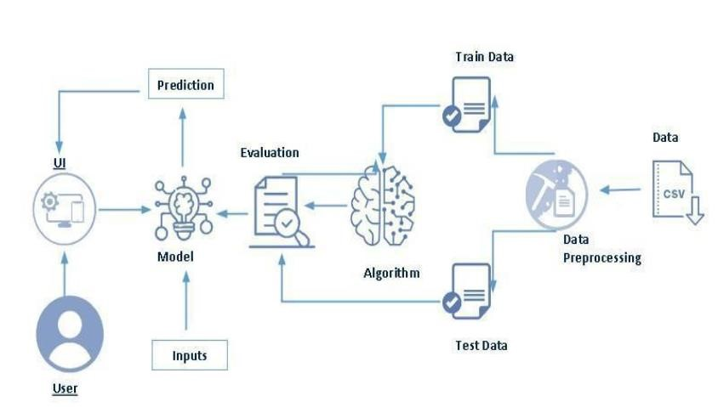

This diagram illustrates a machine learning workflow, starting from data collection to making predictions for users. Raw data, typically in CSV format, undergoes preprocessing to clean and transform it for use. The preprocessed data is split into training and test sets; the training set is used to build the model using a machine learning algorithm, while the test set evaluates its performance. The trained model, once validated, is deployed to make predictions. These predictions are accessed by users through a user interface, allowing them to input new data and receive predictions based on the trained model.

**3.2. SOFTWARE DESIGNING**

The following is the Software required to complete this project:

* **Google Colab**: Google Colab will serve as the development and execution environment for your predictive modeling, data preprocessing, and model training tasks. It provides a cloud-based Jupyter Notebook environment with access to Python libraries and hardware acceleration.
* **Dataset (CSV File)**: The dataset in CSV format is essential for training and testing your predictive model. It should include historical air quality data, weather information, pollutant levels, and other relevant features.
* **Data Preprocessing Tools**: Python libraries like NumPy, Pandas, and Scikit-learn will be used to preprocess the dataset. This includes handling missing data, feature scaling, and data cleaning.
* **Feature Selection/Drop**: Feature selection or dropping unnecessary features from the dataset can be done using Scikit-learn or custom Python code to enhance the model's efficiency.
* **Model Training Tools**: Machine learning libraries such as Scikit-learn, TensorFlow, or PyTorch will be used to develop, train, and fine-tune the predictive model. Regression or classification models can be considered, depending on the nature of the churn prediction task.
* **Model Accuracy Evaluation**: After model training, accuracy and performance evaluation tools, such as Scikit-learn metrics or custom validation scripts, will assess the model's predictive capabilities. You'll measure the model's ability to predict Telecom customer categories based on historical data.
* **UI Based on Flask Environment**: Flask, a Python web framework, will be used to develop the user interface (UI) for the system. The Flask application will provide a user-friendly platform for users to input user data or view churn predictions
* Google Colab will be the central hub for model development and training, while Flask will facilitate user interaction and data presentation. The dataset, along with data preprocessing, will ensure the quality of the training data, and feature selection will optimize the model. Finally, model accuracy evaluation will confirm the system's predictive capabilities, allowing users to rely on the telecom customer churn prediction.

## 4.EXPERIMENTAL INVESTIGATION

In this project, we have used churn dataset. This dataset is a csv file consisting of labelled data and having the following columns-

1. **Row number**: gives the number of rows.
2. **Customer Id**: specifies the unique ID for the customer.
3. **age**: the age of the customer.
4. **gender**: either male or female.
5. **Number of products** : number of products the customer has with the company.
6. **Purchase quantity**: number of products purchased by the customer.
7. **category**: category of products purchased.
8. **Payment method**: method used for payment (e.g., Credit, Debit, Cash).
9. **Shopping mall**: name or type of the shopping mall.
10. **FLOW CHART**

This flowchart represents the process of market segmentation in response to enterprise demand, guiding the development of marketing strategies. It begins with understanding the enterprise demand, followed by selecting the appropriate segmentation variables. Customer data, including information, consumption records, and behavior data, are utilized to inform this selection. The next step involves choosing the related technology for segmentation analysis, such as cluster analysis, artificial neural networks, or decision trees. Once the appropriate technology is selected, segmentation results are analyzed to identify distinct customer segments. Finally, these insights are used to develop targeted marketing strategies, tailored to the needs and behaviors of each segment, thus enhancing the effectiveness of marketing efforts

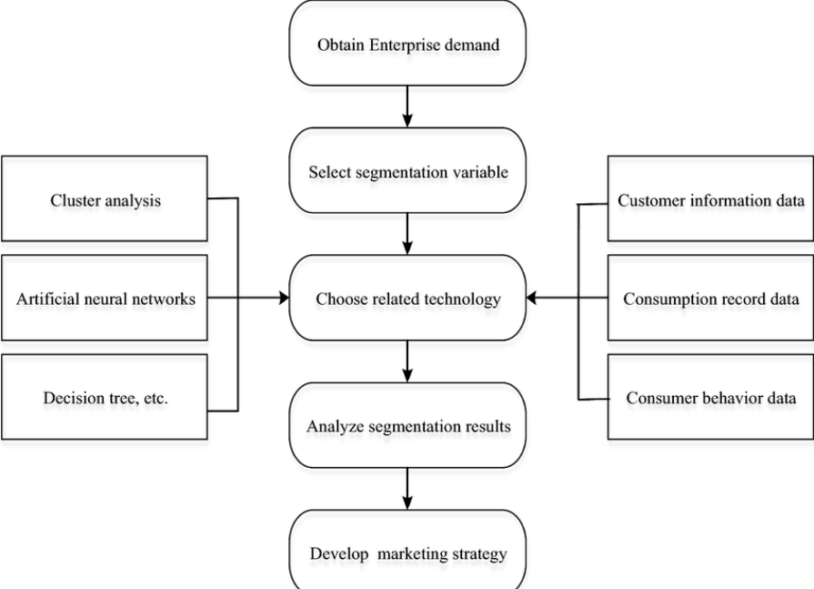

## 6.RESULT

**HOME PAGE**

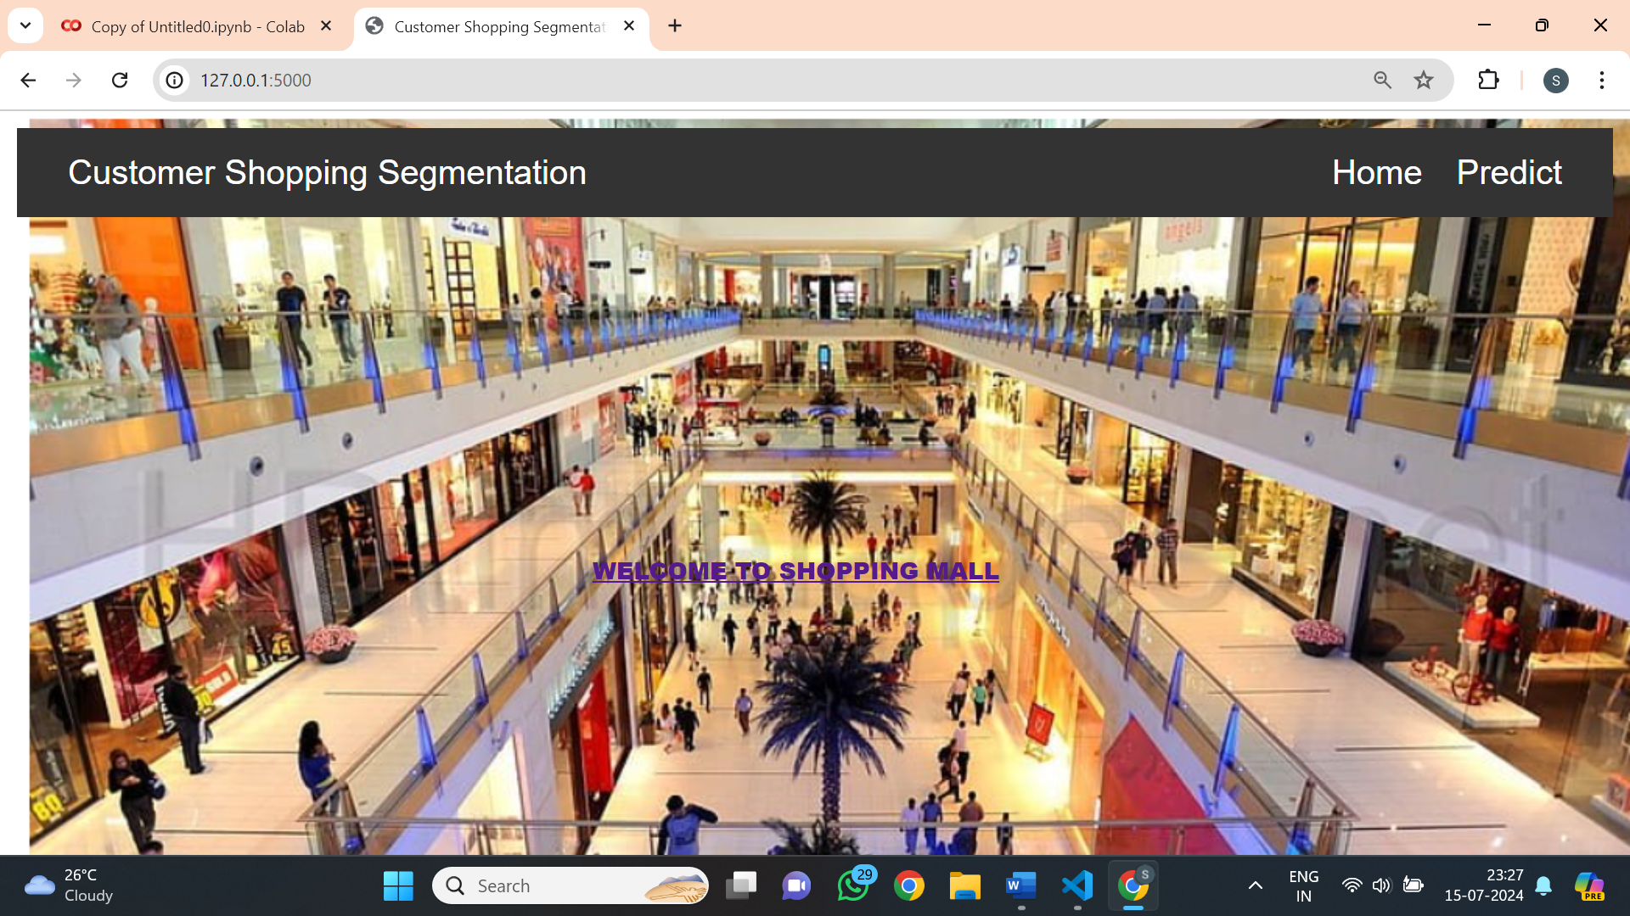

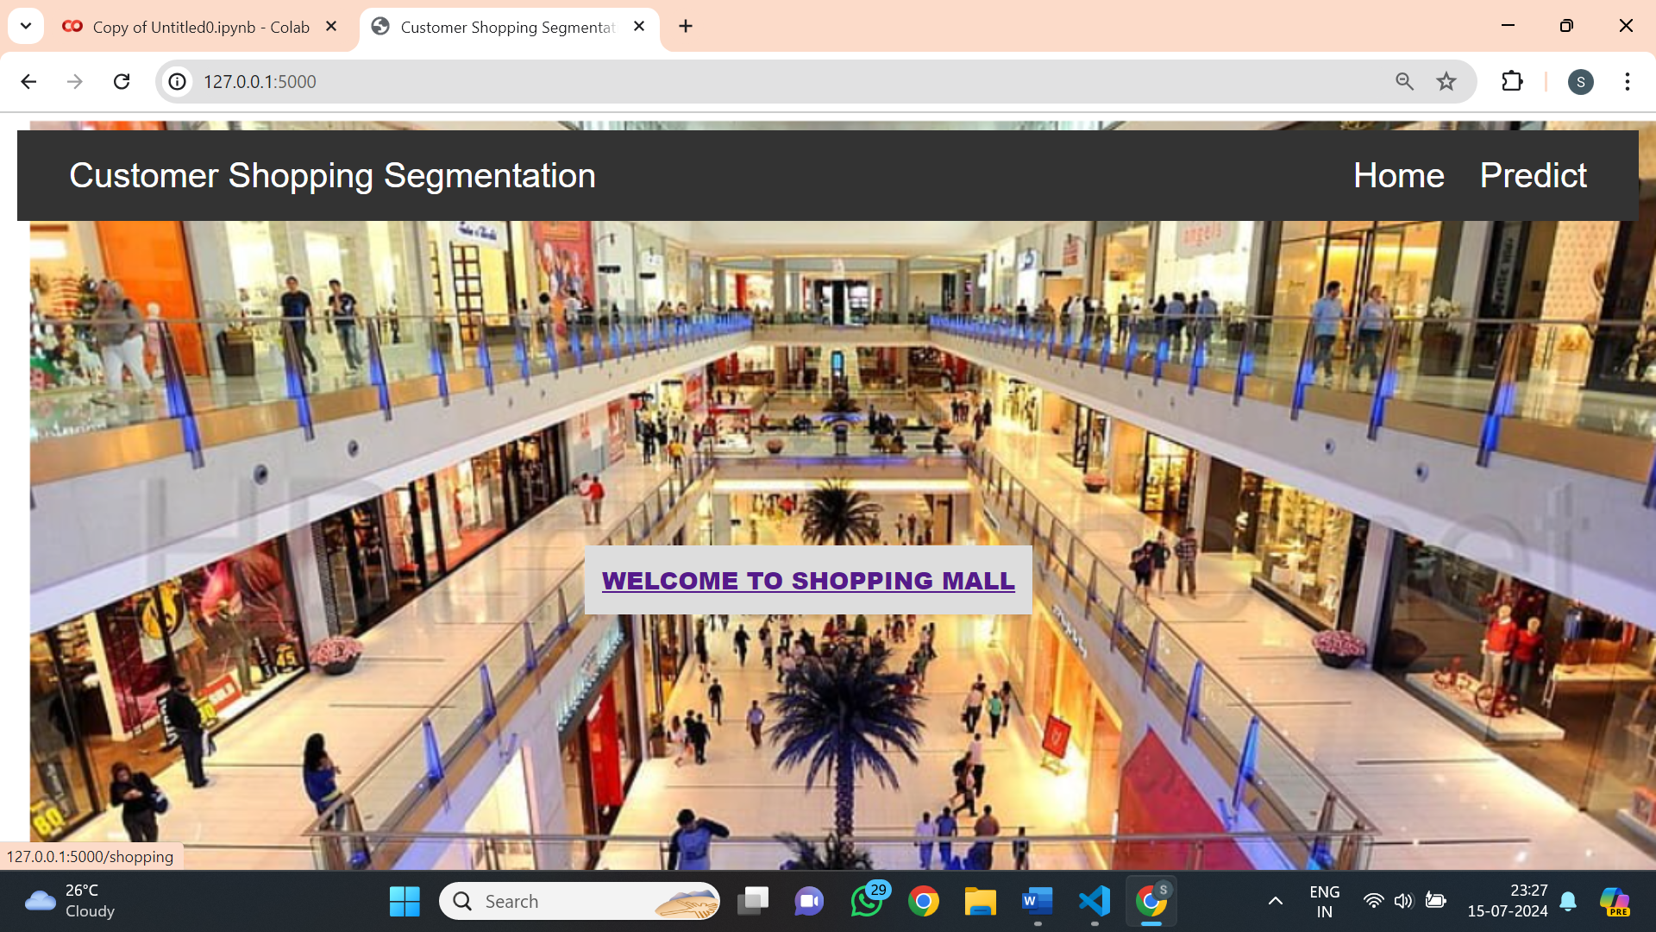

**PREDICTIONS**

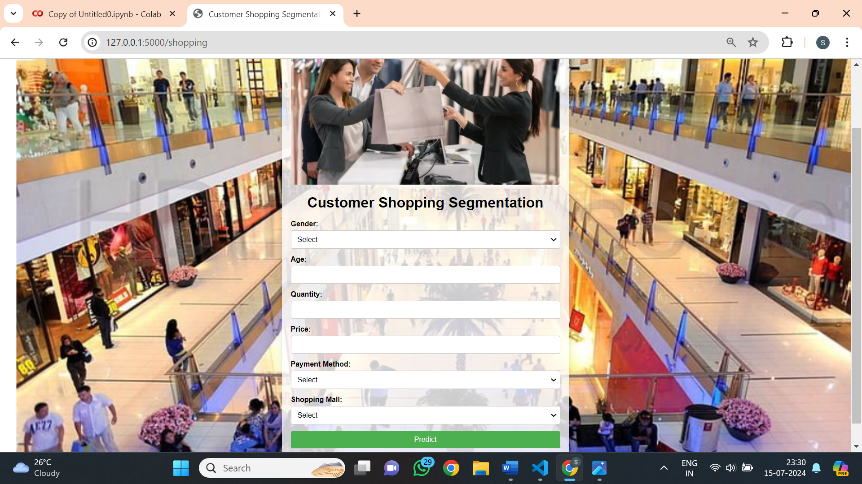

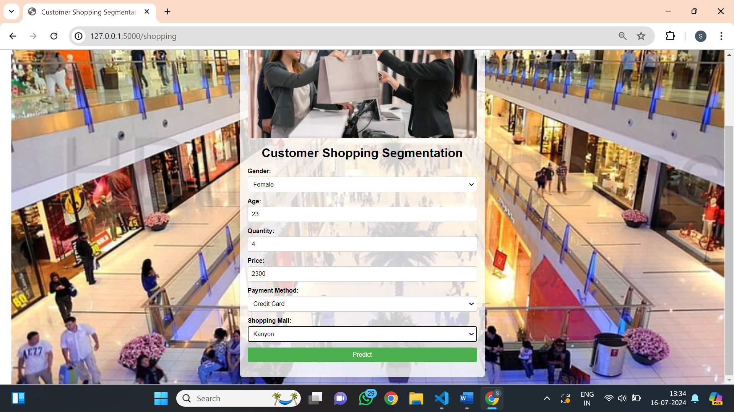

## 7.ADVANTAGES AND DISADVANTAGES

1. **Improved Customer Retention**:By understanding customer segments, businesses can tailor their engagement strategies to retain customers more effectively, reducing churn rates and fostering long-term loyalty.
2. **Enhanced Customer Experience**:: Segmentation allows businesses to offer a more personalized shopping experience, which can lead to higher customer satisfaction and loyalty. Personalized recommendations and offers enhance the overall shopping journey.
3. **Efficient Resource Allocation**:Businesses can allocate resources more efficiently by targeting high-value customer segments, optimizing marketing spend, and improving ROI. This ensures that marketing efforts are focused where they can have the greatest impact.
4. **Better Product Recommendations**: Machine learning can analyze purchasing patterns to recommend products that customers are more likely to buy, increasing cross-selling and up-selling opportunities. This leads to increased average order value and sales.
5. **Data-Driven Decision Making**: Businesses can make more informed decisions based on data-driven insights from customer segmentation analysis. This reduces reliance on intuition and guesswork, leading to more effective strategies.
6. **Identification of New Market Opportunities**:Machine learning can uncover hidden patterns and trends in customer data, revealing new market opportunities and unmet customer needs. This can drive innovation and the development of new products or services.
7. **Improved Customer Insights**: Detailed segmentation provides deeper insights into customer behavior, preferences, and motivations. This helps businesses understand their customers better and tailor their offerings accordingly.

**DISADVANTAGES:**

1. **Data Quality and Availability**:Incomplete data affects prediction accuracy.Privacy and security concerns with large data handling.
2. **Model Complexity**:Requires specialized data science expertise.Models need constant updates and retraining.
3. **Cost and Resources**:High initial setup costs.Ongoing maintenance requires continuous investment.
4. **False Positives/Negatives**:Risk of incorrect predictions leading to misguided strategies.
5. **Customer Reaction**:Targeted efforts may be seen as intrusive.Focus on churn prediction might neglect other important areas.

## 8.APPLICATIONS

**1.Targeted Marketing Campaigns**: Create customized promotion to retain high-risk customers and improve loyalty.

2.**Customer Service Improvement**:Proactively address customer issues to enhance service quality and reduce churn.

3. **Resource Allocation**:Allocate marketing and retention resources more effectively by focusing on high-risk customers.

4.**Product Development**:Identify and improve features or services based on churn reasons to better meet customer needs.

5. **Business Strategy and Planning**:Use churn prediction data to inform strategic decisions and long-term planning for better business outcomes.

## 9.CONCLUSION

## Telecom customer churn prediction is a powerful tool that enables companies to anticipate and mitigate customer loss. By leveraging advanced data analytics and predictive modeling, telecom providers can proactively address the factors leading to churn, thereby enhancing customer retention and satisfaction. This strategic approach not only optimizes resource allocation and operational efficiency but also drives revenue growth and competitive advantage. Despite challenges such as data quality, model complexity, and the need for continuous updates, the benefits of implementing churn prediction far outweigh the drawbacks. Ultimately, effective churn prediction fosters stronger customer relationships, leading to long-term business success in the highly competitive telecom industry.

## 10.FUTURE SCOPE

### Future Scopes of Telecom Customer Churn Prediction

1. **Advanced Predictive Analytics**:Utilizing AI, machine learning, and deep learning for more accurate and real-time churn predictions.
2. **Real-Time Data Integration**:Leveraging data from IoT and 5G networks for granular insights and real-time churn detection.
3. **Enhanced Customer Personalization**:Creating highly personalized customer experiences and contextual marketing strategies based on behavioral analytics.
4. **Automated Retention Solutions**:Implementing AI-powered chatbots and self-service platforms for proactive, automated customer support.
5. **Customer Journey Mapping**: Mapping the entire customer journey to identify critical touchpoints and potential churn triggers. Using predictive analytics to engage customers at crucial moments in their journey.

**11.BIBILOGRAPHY**

[1] Ke, Xueqin, et al. "A review on predicting customer churn in telecommunication." IEEE Access 7 (2019): 58757-58771.

[2]Verbeke, Wouter, et al. "New insights into churn prediction in the telecommunication sector: A profit driven data mining approach." European Journal of Operational Research 218.1 (2012): 211-229.

[3] Kim, Hyoung Goo, and M. Eric Johnson. "A dynamic model of customer retention for telecommunications services." Management Science 49.2 (2003): 150-164.

[4] Tsai, Chung-Hsien, and Yu-Ming Lee. "Applying data mining to telecom churn management." Expert Systems with Applications 31.3 (2006): 515-524.

[5]Tuzhilin, Alexander, and Padhraic Smyth. "Clustering the customers based on the churn behavior." Proceedings of the Fifth ACM SIGKDD International Conference on Knowledge Discovery and Data Mining (1999): 183-186.

[6] Bharti, Alok, and Sunil Verma. "Predictive modeling for customer churn in telecom using machine learning algorithms." International Journal of Computer Applications 129.11 (2015): 19-24.

[7] Iqbal, Asif, and Athar Mahboob. "A survey of churn prediction in telecommunication." Journal of Computer Networks and Communications 2016 (2016).

[8] Gupta, Anuj, et al. "Customer churn prediction in telecom using machine learning in big data platform." Procedia Computer Science 132 (2018): 1579-1585.

[9 ] Srinivasan, S., et al. "Telecom churn prediction using machine learning algorithms: An empirical comparison of classifiers." International Journal of Applied Engineering Research 12.8 (2017): 1822-1827.

[10] Wang, Cheng, et al. "Telecom customer churn prediction using machine learning." IEEE International Conference on Big Data (2017): 3245-3254.

## 12.APPENDIX

**Model building :**

1)Dataset

2)jupyter Notebook and Spyder Application Building

1. HTML file (Index file, home file,Predictyes file ,predictno file)

1. CSS file
2. Models in pickle format

**SOURCE CODE:**

**INDEX3.HTML**

<!DOCTYPE html>

<html lang="en">

<head>

    <meta charset="UTF-8">

    <title>Customer Shopping Segmentation Prediction</title>

    <style>

        body {

            font-family: Arial, sans-serif;

            background-color: #f0f0f0;

            margin: 0;

            padding: 0;

            background-image: url("../static/Screenshot (13).png");

            background-repeat: no-repeat;

            background-size: cover;

        }

        .container {

            max-width: 600px;

            margin:20px auto;

            background-color: rgba(255, 255, 255, 0.8);

            padding: 20px;

            border-radius: 8px;

            box-shadow: 0 0 10px rgba(0, 0, 0, 0.1);

        }

        h1 {

            text-align: center;

            margin-bottom: 20px;

        }

        .form-group {

            margin-bottom: 15px;

        }

        label {

            display: block;

            margin-bottom: 5px;

            font-weight: bold;

        }

        input[type="number"],

        input[type="text"],

        select,

        button {

            width: 100%;

            padding: 10px;

            font-size: 16px;

            border: 1px solid #ccc;

            border-radius: 4px;

            box-sizing: border-box;

        }

        button {

            background-color: #4CAF50;

            color: white;

            border: none;

            cursor: pointer;

        }

        button:hover {

            background-color: #45a049;

        }

        #prediction-result {

            margin-top: 20px;

            font-size: 18px;

            text-align: center;

        }

        .logo {

            display: block;

            margin: 20px auto;

            max-width: 100%;

            height: auto;

            border-radius: 8px;

        }

    </style>

</head>

<body>

    <div class="container">

        <img src="../static/predict.png" alt="Customer Segmentation" class="logo">

        <h1>Customer Shopping Segmentation</h1>

        <form id="prediction-form">

            <div class="form-group">

                <label for="gender">Gender:</label>

                <select id="gender" name="gender" required>

                    <option value="">Select</option>

                    <option value="Male">Male</option>

                    <option value="Female">Female</option>

                    <option value="Other">Other</option>

                </select>

            </div>

            <div class="form-group">

                <label for="age">Age:</label>

                <input type="number" id="age" name="age" required>

            </div>

            <div class="form-group">

                <label for="quantity">Quantity:</label>

                <input type="number" id="quantity" name="quantity" required>

            </div>

            <div class="form-group">

                <label for="price">Price:</label>

                <input type="number" id="price" name="price" step="0.01" required>

            </div>

            <div class="form-group">

                <label for="payment_method">Payment Method:</label>

                <select id="payment_method" name="payment_method" required>

                    <option value="">Select</option>

                    <option value="Credit Card">Credit Card</option>

                    <option value="Debit Card">Debit Card</option>

                    <option value="Cash">Cash</option>

                </select>

            </div>

            <div class="form-group">

                <label for="shopping_mall">Shopping Mall:</label>

                <select id="shopping_mall" name="shopping_mall" required>

                    <option value="">Select</option>

                    <option value="Kanyon">Kanyon</option>

                    <option value="Forum Istanbul">Forum Istanbul</option>

                    <option value="Metrocity">Metrocity</option>

                    <option value="Metropol AVM">Metropol AVM</option>

                    <option value="Istinye Park">Istinye Park</option>

                    <option value="Mall of Istanbul">Mall of Istanbul</option>

                    <option value="Emaar Square Mall">Emaar Square Mall</option>

                    <option value="Cevahir AVM">Cevahir AVM</option>

                    <option value="Viaport Outlet">Viaport Outlet</option>

                    <option value="Zorlu Center">Zorlu Center</option>

                </select>

            </div>

            <button type="button" onclick="submitForm()">Predict</button>

        </form>

        <p id="prediction-result"></p>

    </div>

    <script>

        async function submitForm() {

            const form = document.getElementById('prediction-form');

            const formData = new FormData(form);

            const jsonData = {};

            formData.forEach((value, key) => {

                jsonData[key] = value;

            });

            try {

                const response = await fetch('/predict', {

                    method: 'POST',

                    headers: {

                        'Content-Type': 'application/json'

                    },

                    body: JSON.stringify(jsonData)

                });

                const result = await response.json();

                if (response.ok) {

                    document.getElementById('prediction-result').textContent = `Predicted Cluster: ${result.predicted_cluster}`;

                } else {

                    document.getElementById('prediction-result').textContent = `Error: ${result.error}`;

                }

            } catch (error) {

                console.error('Error:', error);

                document.getElementById('prediction-result').textContent = `Error: ${error.message}`;

            }

        }

    </script>

</body>

</html>

**Shopping.html:**

<!DOCTYPE html>

<html lang="en">

<head>

    <meta charset="UTF-8">

    <meta name="viewport" content="width=device-width, initial-scale=1.0">

    <title>Customer Shopping Segmentation</title>

    <style>

        /* Reset default margin and padding */

        * {

            margin: 0;

            padding: 0;

            box-sizing: border-box;

        }

        body {

            font-family: Arial, sans-serif;

            background-image: url("../static/Screenshot (13).png");

            background-repeat: no-repeat;

            background-size: cover;

            padding: 20px;

            margin: 0;

            display: flex;

            flex-direction: column;

            align-items: center;

            height: 100vh;

        }

        .navbar {

            background-color: #333;

            overflow: hidden;

            padding: 10px 20px;

            width: 100%;

            z-index: 1;

        }

        .navbar a {

            float: right;

            display: block;

            color: white;

            text-align: center;

            padding: 10px 20px;

            text-decoration: none;

            transition: background-color 0.3s;

        }

        .navbar a:hover {

            background-color: #ddd;

            color: black;

        }

        .content {

            flex: 1;

            display: flex;

            justify-content: center;

            align-items: center;

            flex-direction: column;

            text-align: center;

        }

        button {

            background-color: transparent;

            border: none;

            padding: 20px;

            color: #333;

            font-size: 28px;

            font-family: 'Arial Black', sans-serif; /* Example of different font */

            text-transform: uppercase; /* Example of uppercase text */

            cursor: pointer;

            transition: background-color 0.3s, color 0.3s;

        }

        button:hover {

            background-color: #ddd;

            color: black;

        }

    </style>

</head>

<body>

<div class="navbar">

    <div class="navbar-text">Customer Shopping Segmentation</div>

    <a href="#predict">Predict</a>

    <a href="#home">Home</a>

</div>

<div class="content">

    <form>

        <button type="submit">Welcome to Shopping Mall</button>

    </form>

</div>

</body>

</html>

**Index.html:**

<!DOCTYPE html>

<html lang="en">

<head>

    <meta charset="UTF-8">

    <meta name="viewport" content="width=device-width, initial-scale=1.0">

    <title>Customer Shopping Segmentation</title>

    <style>

        /* Reset default margin and padding */

        * {

            margin: 0;

            padding: 0;

            box-sizing: border-box;

        }

        body {

            font-family: Arial, sans-serif;

            background-image: url("../static/Screenshot (13).png");

            background-repeat: no-repeat;

            background-size: cover;

            padding: 20px;

            margin: 0;

        }

        .navbar {

            background-color: #333;

            overflow: hidden;

            padding: 20px 40px;

            position: relative;

            z-index: 1;

        }

        .navbar-text {

            font-size:24px;

            color: white;

            float: left;

            margin-right: 20px;

            line-height: 40px;

        }

        .navbar a{

            font-size:40px;

            float: right;

            display: block;

            color: white;

            text-align: center;

            padding: 10px 20px;

            text-decoration: none;

            transition: background-color 0.3s;

        }

        .navbar div{

            font-size:40px;

            float: left;

            display: block;

            color: white;

            text-align: center;

            padding: 10px 20px;

            text-decoration: none;

            transition: background-color 0.3s;

        }

        .navbar a:hover {

            background-color: #ddd;

            color: black;

        }

        button {

            background-color: transparent;

            border: none;

            padding: 20px;

            color: #333;

            font-size: 28px;

            font-family: 'Arial Black', sans-serif; /* Example of different font */

            text-transform: uppercase; /* Example of uppercase text */

            cursor: pointer;

            transition: background-color 0.3s, color 0.3s;

            margin-top:20%;

            margin-left:35%;

        }

        button:hover{

            background-color: #ddd;

            color: black;

        }

    </style>

</head>

<body>

    <div class="navbar">

        <div><font color="white",size='40px'>Customer Shopping Segmentation</font></div>

        <a href="/shopping">Predict</a>

        <a href="/">Home</a>

    </div>

    <form>

   <button type="submit"><a href="/shopping">WELCOME TO SHOPPING MALL</a></button>

</form>

</body>

</html>

**APP.PY**

from flask import Flask, request, jsonify, render_template

import pandas as pd

from sklearn.preprocessing import LabelEncoder

import joblib

app = Flask(__name__)

# Load the model and scaler

model = joblib.load('kmeans_model5.pkl')

scaler = joblib.load('scaler5.pkl')

label_encoders=joblib.load("label_encoders5.pkl")

@app.route('/')

def welcome():

    return render_template('index.html')

@app.route('/shopping')

def shopping():

    return render_template('index3.html')

@app.route('/predict', methods=['POST'])

def predict():

    try:

        data = request.get_json()

        print(f"Received data: {data}")

        # Validate incoming data

        required_fields = ['gender','payment_method', 'shopping_mall', 'age', 'quantity', 'price']

        for field in required_fields:

            if field not in data:

                raise ValueError(f"Missing field: {field}")

        # Convert data into DataFrame

        df = pd.DataFrame([data])

        print("data is",df)

        # Encoding categorical variables

        for column in ['gender', 'payment_method', 'shopping_mall']:

            if column in label_encoders:

                le = label_encoders[column]

                print(f"Label Encoder classes for {column}: {le.classes_}")

                if data[column] not in le.classes_:

                    raise ValueError(f"Value '{data[column]}' for column '{column}' not found in label encoder classes.")

                df[column] = le.transform([data[column]])

            else:

                raise ValueError(f"No label encoder found for column: {column}")

        # Feature scaling

        print(f"Data before scaling: {df[['age', 'quantity', 'price']]}")

        df[['age', 'quantity', 'price']] = scaler.transform(df[['age', 'quantity', 'price']])

        print(f"Data after scaling: {df[['age', 'quantity', 'price']]}")

        # Making predictions

        print(f"Data before prediction: {df}")

        prediction = model.predict(df)

        print(f"Predicted cluster: {prediction[0]}")

        return jsonify({'predicted_cluster': int(prediction[0])})

    except ValueError as ve:

        #print(f"Validation Error: {ve}")

        return jsonify({'error': str(ve)}), 400

    except Exception as e:

        #print(f"Error: {e}")

        return jsonify({'error': str(e)}), 400

if __name__ == '__main__':

    app.run(debug=True)

## CODE SNIPPETS

### MODEL BUILDING



